Guinea

## GNI per capita and development level

The data set shows the GNI per capita and development level of the country each year.

## # A tibble: 19 x 5  
## country iso3c date GNIperCapita devCategory  
## <chr> <chr> <dbl> <dbl> <chr>   
## 1 Guinea GIN 1996 350. Low Income   
## 2 Guinea GIN 1998 351. Low Income   
## 3 Guinea GIN 2000 341. Low Income   
## 4 Guinea GIN 2002 594. Low Income   
## 5 Guinea GIN 2003 403. Low Income   
## 6 Guinea GIN 2004 356. Low Income   
## 7 Guinea GIN 2005 382. Low Income   
## 8 Guinea GIN 2006 633. Low Income   
## 9 Guinea GIN 2007 661. Low Income   
## 10 Guinea GIN 2008 671. Low Income   
## 11 Guinea GIN 2009 641. Low Income   
## 12 Guinea GIN 2010 665. Low Income   
## 13 Guinea GIN 2011 681. Low Income   
## 14 Guinea GIN 2012 708. Low Income   
## 15 Guinea GIN 2013 696. Low Income   
## 16 Guinea GIN 2014 717. Low Income   
## 17 Guinea GIN 2015 738. Low Income   
## 18 Guinea GIN 2016 796. Low Income   
## 19 Guinea GIN 2017 865. Low Income

## GDP growth and economic growth classification

The data set shows the GDP growth and the ecomic growth classification of the country each year.

## # A tibble: 19 x 5  
## country iso3c date GDPannualGrowthRate GDPgrowthCategory4  
## <chr> <chr> <dbl> <dbl> <fct>   
## 1 Guinea GIN 1996 4.46 moderate growth   
## 2 Guinea GIN 1998 3.64 moderate growth   
## 3 Guinea GIN 2000 2.50 moderate growth   
## 4 Guinea GIN 2002 5.16 moderate growth   
## 5 Guinea GIN 2003 1.25 slow growth   
## 6 Guinea GIN 2004 2.34 slow growth   
## 7 Guinea GIN 2005 3.00 moderate growth   
## 8 Guinea GIN 2006 1.16 slow growth   
## 9 Guinea GIN 2007 6.83 fast growth   
## 10 Guinea GIN 2008 4.14 moderate growth   
## 11 Guinea GIN 2009 -1.12 negative grwoth   
## 12 Guinea GIN 2010 4.82 moderate growth   
## 13 Guinea GIN 2011 5.61 fast growth   
## 14 Guinea GIN 2012 5.92 fast growth   
## 15 Guinea GIN 2013 3.93 moderate growth   
## 16 Guinea GIN 2014 3.71 moderate growth   
## 17 Guinea GIN 2015 3.81 moderate growth   
## 18 Guinea GIN 2016 10.8 fast growth   
## 19 Guinea GIN 2017 10.3 fast growth

## Development trend

The plot shows the development trend of the country.

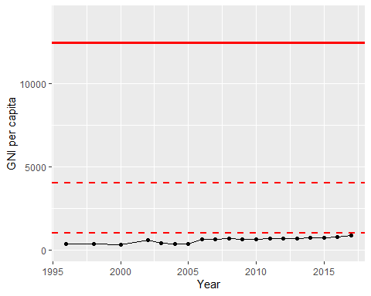

GNI Per Capita Trend